Nicholas Russell

Professor Labouseur

4 November 2014

Database Systems Management

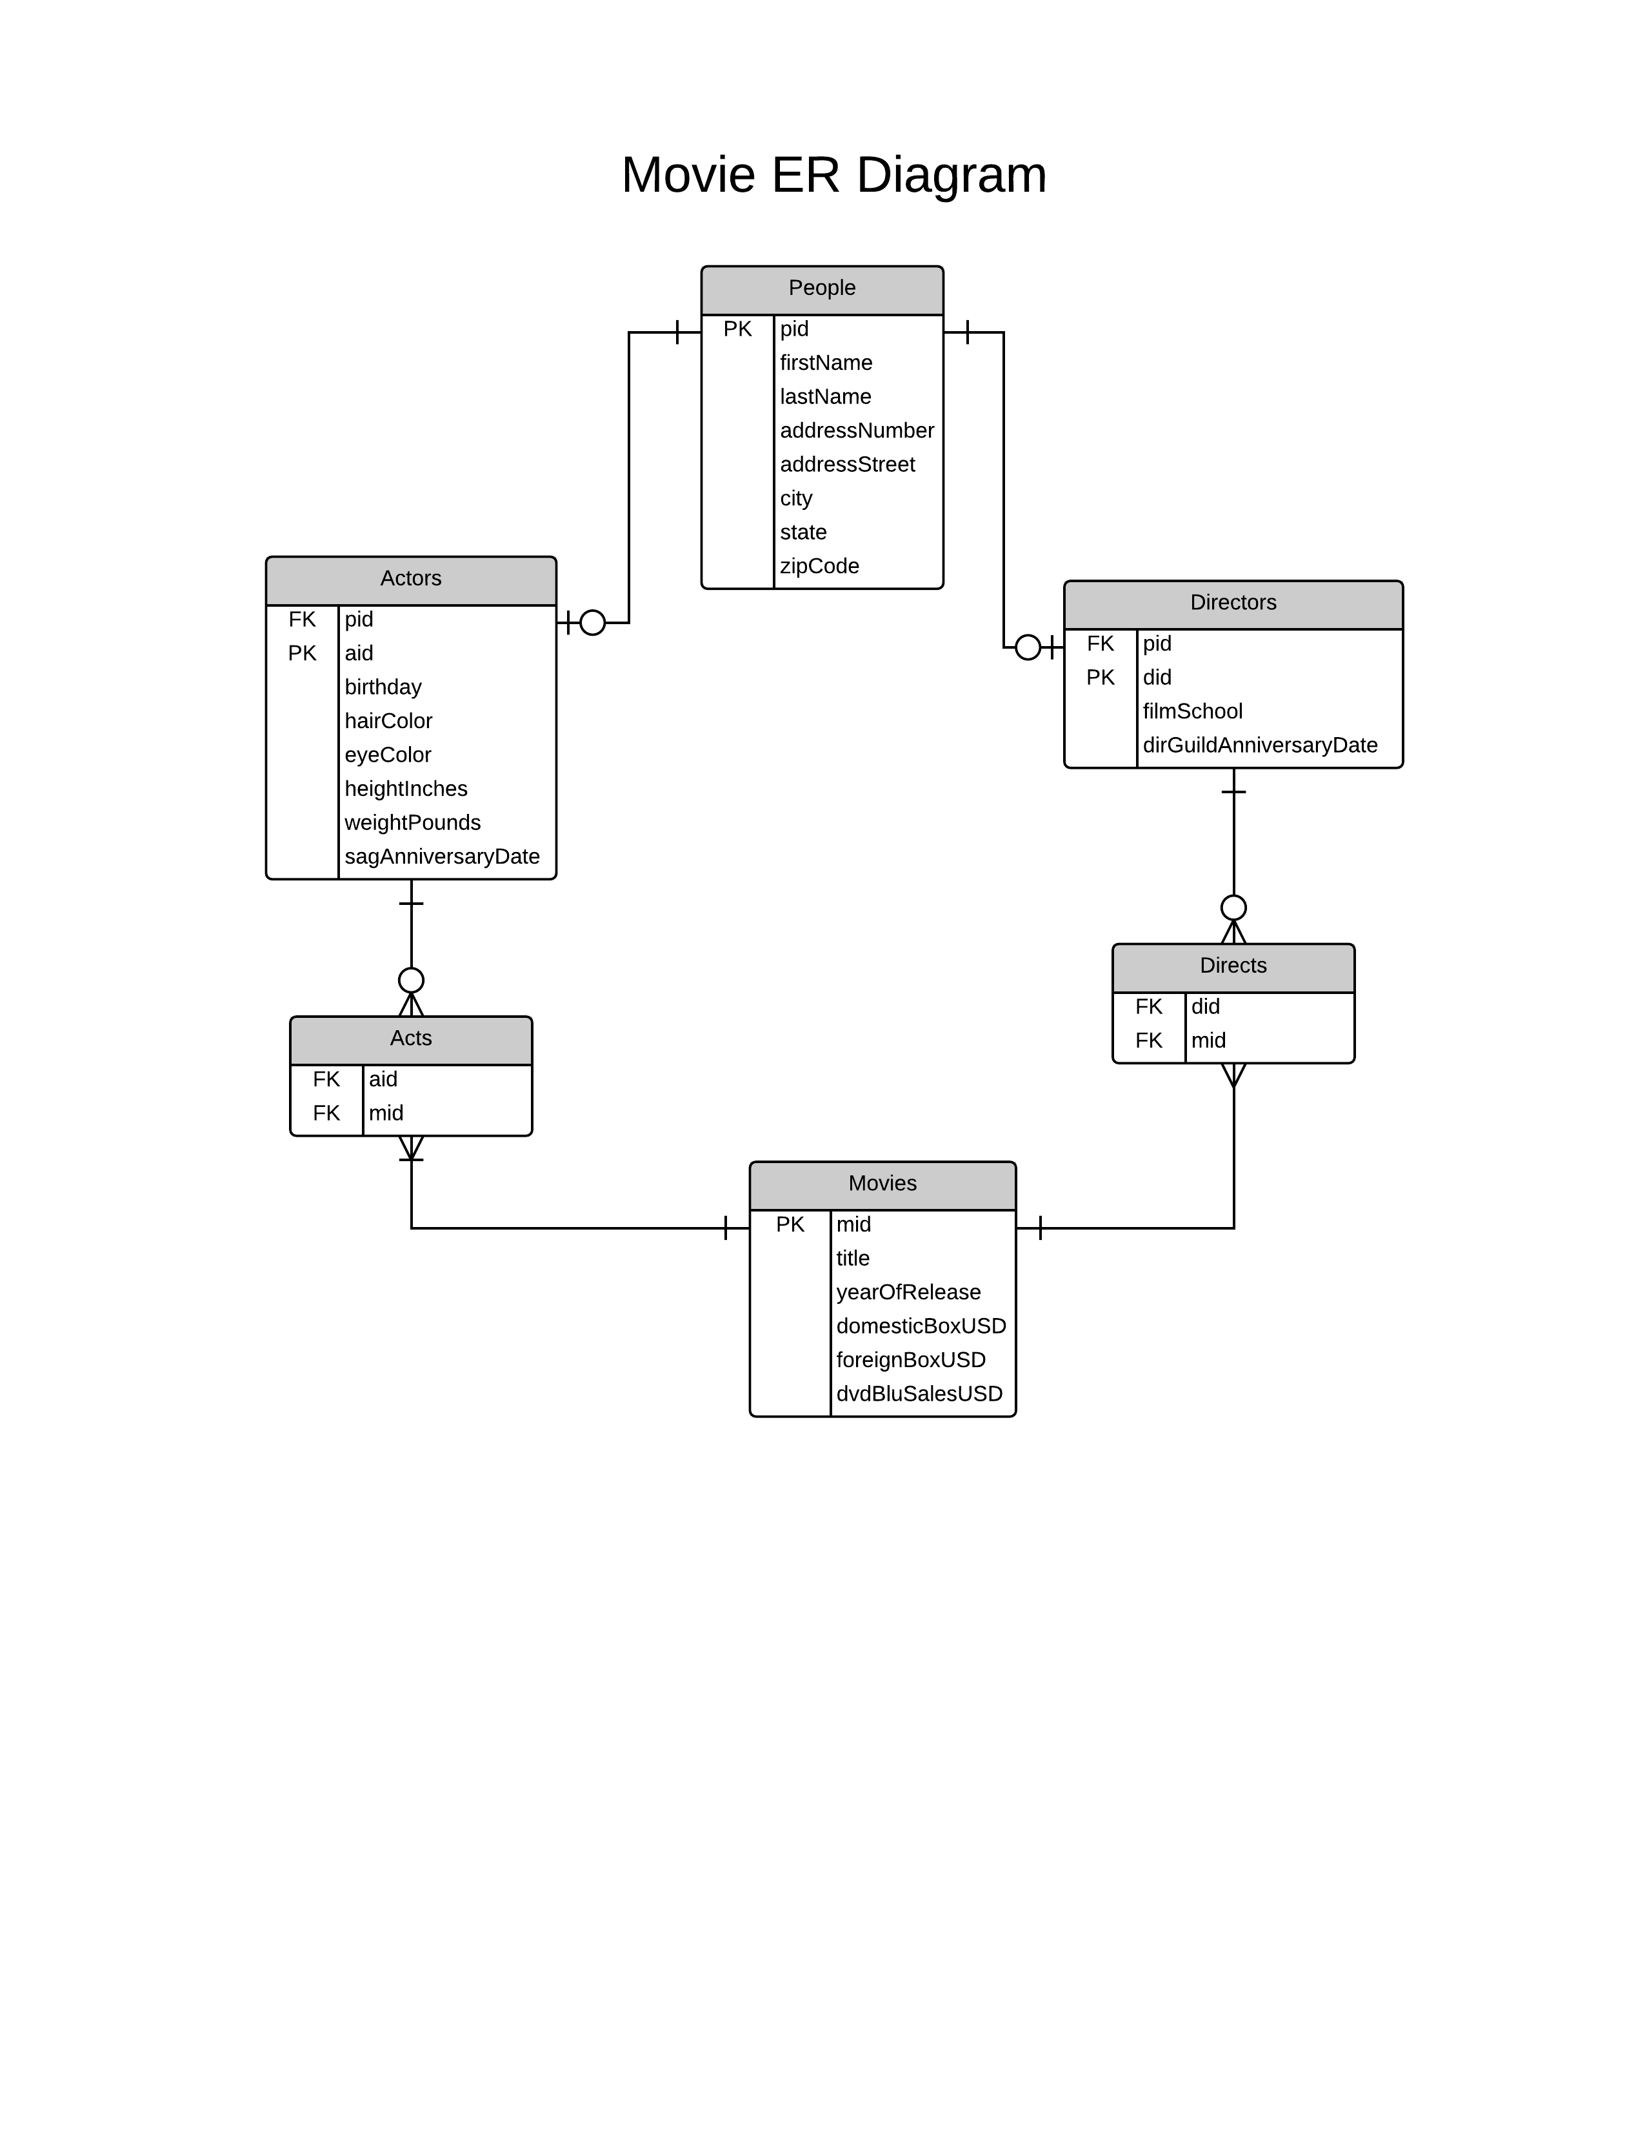Lab 8: Normalization Two

1) Here is an ER Diagram of the Data:

**PEOPLE DATA**

Here are the SQL Statements for the first table, People:

CREATE TABLE people(

pid char(3) NOT NULL,

firstName text,

lastName text,

addressNumber int,

addressStreet text,

city text,

state text,

zipCode int,

primary key(pid)

);

INSERT INTO people(pid, firstName, lastName, addressNumber, addressStreet, city, state, zipCode)

VALUES ('p01', 'Sean', 'Connery', 6220, 'Del Valle Drive', 'Los Angeles', 'CA', 90048),

('p02', 'Joseph', 'Gordon-Levitt', 8820, 'Wilshire Blvd', 'Beverly Hills', 'CA', 90211),

('p03', 'Joaquin', 'Phoenix', 9171, 'Wilshire Blvd', 'Beverly Hills', 'CA', 90210),

('p04', 'Christopher', 'Nolan', 10880, 'Wilshire Blvd', 'Beverly Hills', 'CA', 90024),

('p05', 'Leonardo', 'Dicaprio', 9225, 'Sunset Blvd', 'West Hollywood', 'CA', 90069),

('p06', 'Mark', 'Ruffalo', 9150, 'Main Street', 'Tucson', 'AZ', 85701),

('p07', 'Bennett', 'Miller', 1250, 'Park Avenue', 'New York', 'NY', 10021),

('p08', 'Javier', 'Bardem', 12, 'Herring Street', 'Harrington Park', 'NJ', 07640),

('p09', 'Terence', 'Young', 11, 'Broadway Avenue', 'Port Richey', 'FL', 34668),

('p10', 'Joel', 'Coen', 30, 'East 10th Street', 'New York', 'NY', 10003),

('p11', 'Ethan', 'Coen', 30, 'East 10th Street', 'New York', 'NY', 10003),

('p12', 'Spike', 'Jonze', 20, 'Parva Ave', 'Los Angeles', 'CA', 90027);

The following statements produce a table that looks like the following:

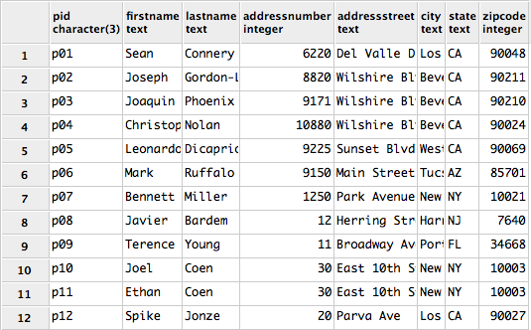 select *

from people;

The functional dependencies are the following:

pid 🡪 firstName, lastName, addressNumber, addressStreet, city, state, zipcode

**ACTORS DATA**

Next, the actors table looks like the following:

CREATE TABLE actors(

aid char(3) NOT NULL,

pid char(3) NOT NULL references people(pid),

birthday char(10),

hairColor text,

eyeColor text,

heightInches int,

weightPounds int,

sagAnniversaryDate char(10),

primary key (aid)

);

INSERT INTO actors(aid, pid, birthday, hairColor, eyeColor, heightInches, weightPounds, sagAnniversaryDate)

VALUES ('a01', 'p01', '08/25/1930', 'grey', 'black', 74, 210, '10/12/1975'),

('a02', 'p02', '02/17/1981', 'brown', 'black', 69, 185,

'12/15/2008'),

('a03', 'p03', '10/28/1974', 'brown', 'blue', 68, 175, '01/25/2001'),

('a04', 'p05', '11/11/1974', 'black', 'green', 72, 190, '05/21/1999'),

('a05', 'p06', '11/22/1967', 'grey', 'brown', 68, 192, '04/12/2005'),

('a06', 'p08', '03/01/1969', 'chestnut', 'black', 71, 188, '02/24/2007'),

('a07', 'p12', '10/22/1969', 'blonde', 'blue', 67, 140, '04/04/1994');

The previous SQL statements, when queried, produce the following table:

select *

from actors;

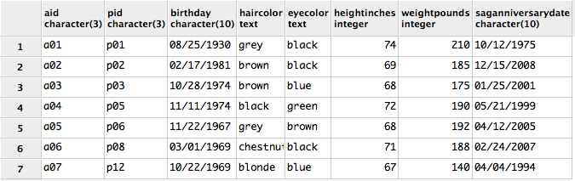

The formal dependency of this table is the following:

aid 🡪 pid, birthday, hairColor, eyeColor, heightInches, weightPounds, sadAnniversaryDate

**DIRECTORS DATA**

The following statements will produce the directors data table:

CREATE TABLE directors(

did char(3) NOT NULL,

pid char(3) NOT NULL references people(pid),

filmSchool text,

dirGuildAnniversaryDate char(10),

primary key (did)

);

INSERT INTO directors(did, pid, filmSchool, dirGuildAnniversaryDate)

VALUES ('d01', 'p02', 'Columbia University', '09/12/2014'),

('d02', 'p04', 'University College London', '08/28/2008'),

('d03', 'p07', 'New York University', '02/24/2001' ),

('d04', 'p09', 'Univeristy of Cambridge', '12/14/1968'),

('d05', 'p10', 'New York University', '09/12/2006'),

('d06', 'p11', 'Princeton University', '09/12/2006') ,

('d07', 'p12', 'San Francisco Art Institute', '10/15/2006');

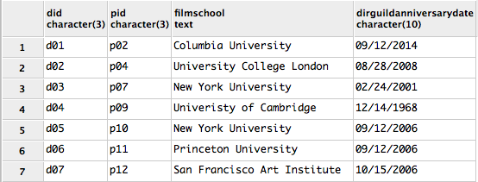The output of the statements up above produce the following:

select *

from directors;

The formal dependencies of the data are the following:

did 🡪 pid, filmschool, dirGuildAnniversaryDate

**Movie Data**

The following statements produced the movie table:

CREATE TABLE movies(

mid char(3) NOT NULL,

title text NOT NULL,

yearOfRelease int,

domesticBoxUSD int,

foreignBoxUSD int,

dvdBluSalesUSD int,

primary key (mid)

);

INSERT INTO movies (mid, title, yearOfRelease, domesticBoxUSD, foreignBoxUSD, dvdBluSalesUSD)

VALUES ('m01', 'Dr. No', 1962, 16067035, 43432965, 10000),

('m02', 'Foxcatcher', 2014, 19000000, 2400000, 0),

('m03', 'Memento', 2001, 25544867, 14178229, 15000000),

('m04', 'No Country for Old Men', 2007, 74283625, 97343541,

51800000),

('m05', 'Don Jon', 2013, 24477704, 5973052, 13000000),

('m06', 'Her', 2013, 25568251, 21783000, 12000000),

('m07', 'Whats Eating Gilbert Grape', 1993, 10032765, 1003453,

125000);

The output of the statements above are as follows:

select *

from movies

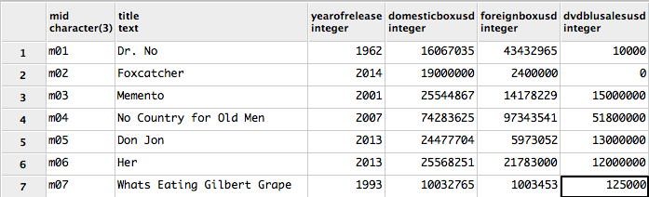

The functional dependencies of this table are as follows:

mid 🡪 title, yearOfRelease, domesticBoxOffice, foreignBoxUSD, dvdBluSales

**Acts table**

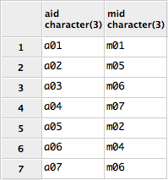The following statements produce the ACTS table:

CREATE TABLE acts(

aid char(3) references actors(aid),

mid char(3) references movies(mid),

primary key (aid, mid)

);

INSERT INTO acts (aid, mid)

VALUES ('a01', 'm01'),

('a02', 'm05'),

('a03', 'm06'),

('a04', 'm07'),

('a05', 'm02'),

('a06', 'm04'),

('a07', 'm06');

The output of the previous statements is to the top-right.

The functional dependencies of this table are as follows:

aid, mid 🡪

**Directs Table**

The following statements produce the DIRECTS table:

CREATE TABLE directs(

did char(3) references directors(did),

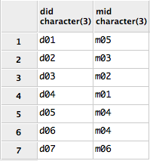 mid char(3) references movies(mid),

primary key (did, mid)

);

INSERT INTO directs (did, mid)

VALUES ('d01', 'm05'),

('d02', 'm03'),

('d03', 'm02'),

('d04', 'm01'),

('d05', 'm04'),

('d06', 'm04'),

('d07', 'm06');

select *

from directs;

The output of the previous statements produce the following:

The functional dependencies of the table are as follows: did, mid 🡪

The following query returns all the directors with whom actor “Sean Connery” has worked with.

select p.firstName, p.lastName

from people p, directors d1

where p.pid = d1.pid

and d1.did = (select d2.did

from directs d2, acts a1, movies m

where a1.mid = m.mid

and d2.mid = m.mid

and a1.aid = (select a2.aid

from actors a2, people p

where a2.pid = p.pid

and p.firstName = 'Sean'

and p.lastName = 'Connery'
)

);